library(dplyr)

library(forecast)

library(ggplot2)

library(urca)

library(zoo)

#1 importing the dataset

btc = read.zoo("E:\\AdvAnal\\RforFin\\data\\bitcoin_price.csv", sep=",", header = TRUE, format = "%b %d, %Y")

btc = window(btc, start = '2016-01-01', end = '2017-12-31')

plot(btc, main = "BITCOIN Closing Prices", ylab = "Close", xlab = "Date", col="cornflowerblue")

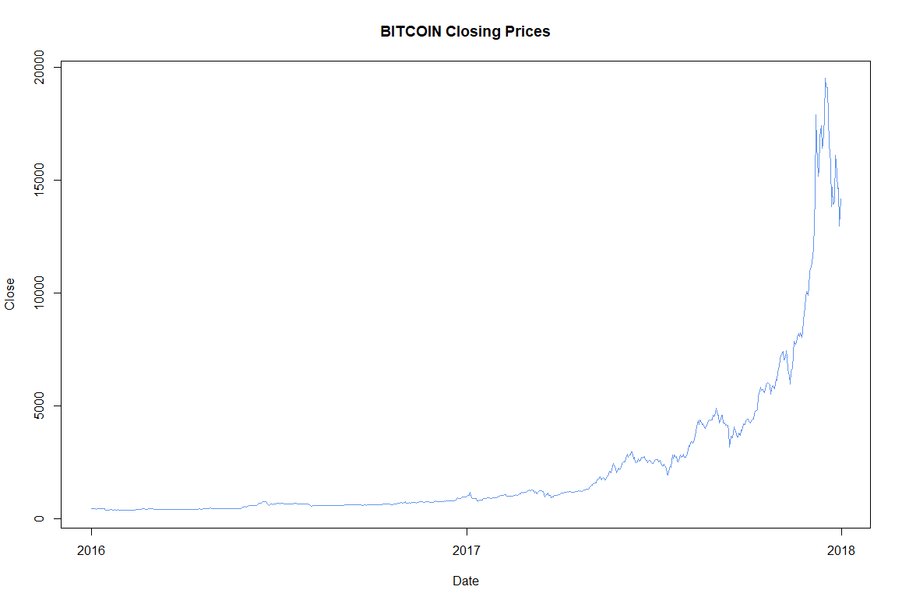

ret_btc = diff(log(btc)) * 100

summary(coredata(ret_btc))

hist(ret_btc, breaks=100, main = "Histogram of Daily Returns", xlab="%", col="cornflowerblue")

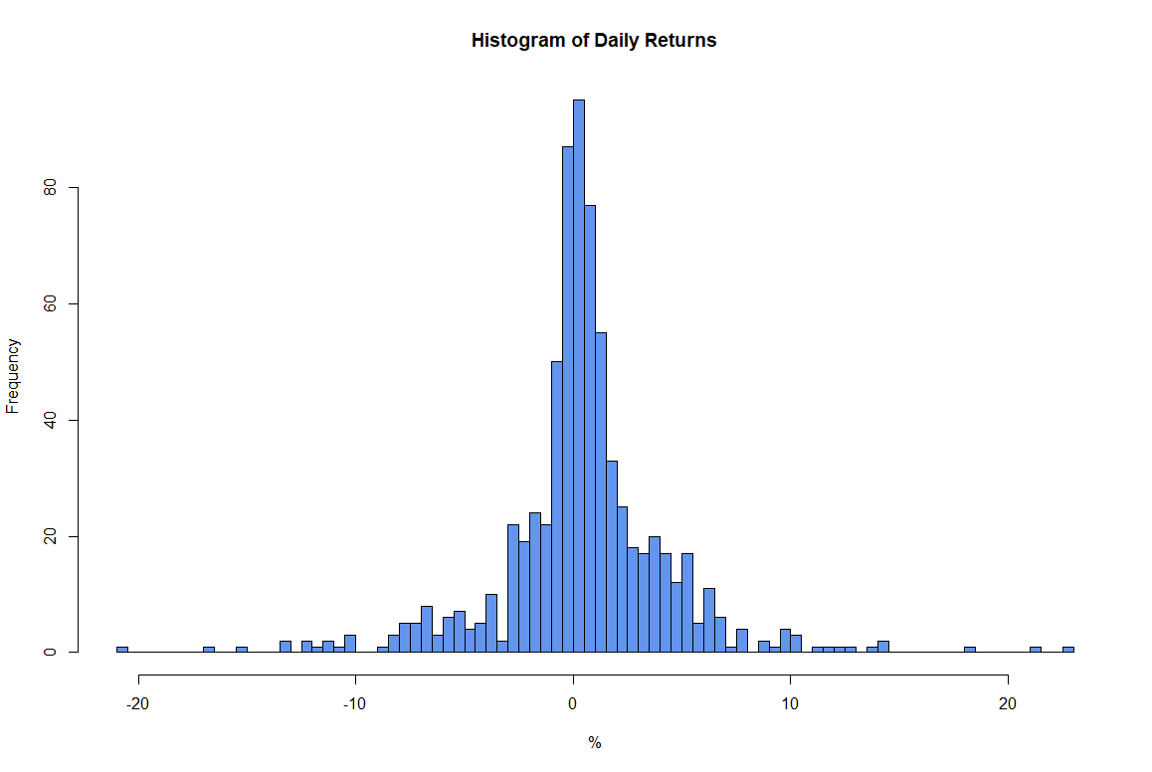

ltc = read.zoo("E:\\AdvAnal\\RforFin\\data\\litecoin_price.csv", sep=",", header = TRUE, format = "%b %d, %Y")

ltc = window(ltc, start = '2016-01-01', end = '2017-12-31')

plot(ltc, main = "LITECOIN Closing Prices", ylab = "Close", xlab = "Date", col="cornflowerblue")

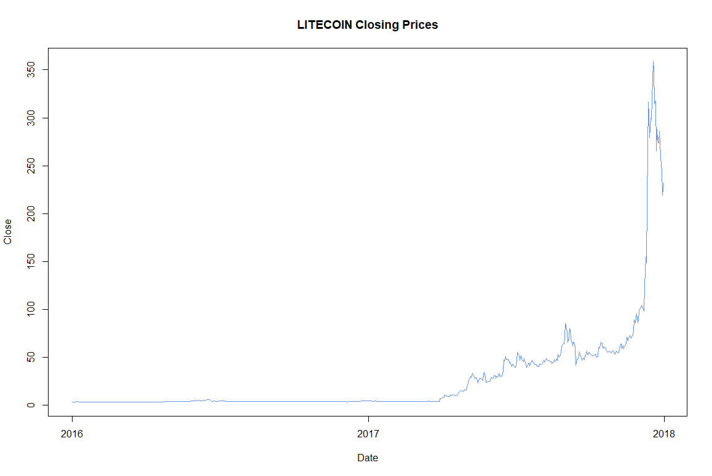

adf_btc <- ur.df(btc, type = "drift")

summary(adf_btc)

###############################################

# Augmented Dickey-Fuller Test Unit Root Test #

###############################################

Test regression drift

Call:

lm(formula = z.diff ~ z.lag.1 + 1 + z.diff.lag)

Residuals:

Min 1Q Median 3Q Max

-1933.7 -19.8 -9.0 9.4 3199.7

Coefficients:

Estimate Std. Error t value Pr(>|t|)

(Intercept) 8.697336 12.666630 0.687 0.493

z.lag.1 0.003338 0.003177 1.051 0.294

z.diff.lag 0.148269 0.037391 3.965 8.05e-05 ***

---

Signif. codes: 0 ‘***’ 0.001 ‘**’ 0.01 ‘*’ 0.05 ‘.’ 0.1 ‘ ’ 1

Residual standard error: 282 on 726 degrees of freedom

Multiple R-squared: 0.02438, Adjusted R-squared: 0.02169

F-statistic: 9.07 on 2 and 726 DF, p-value: 0.0001286

Value of test-statistic is: 1.0506 1.7493

Critical values for test statistics:

1pct 5pct 10pct

tau2 -3.43 -2.86 -2.57

phi1 6.43 4.59 3.78

adf_ltc <- ur.df(btc, type = "drift")

summary(adf_ltc)

###############################################

# Augmented Dickey-Fuller Test Unit Root Test #

###############################################

Test regression drift

Call:

lm(formula = z.diff ~ z.lag.1 + 1 + z.diff.lag)

Residuals:

Min 1Q Median 3Q Max

-1933.7 -19.8 -9.0 9.4 3199.7

Coefficients:

Estimate Std. Error t value Pr(>|t|)

(Intercept) 8.697336 12.666630 0.687 0.493

z.lag.1 0.003338 0.003177 1.051 0.294

z.diff.lag 0.148269 0.037391 3.965 8.05e-05 ***

---

Signif. codes: 0 ‘***’ 0.001 ‘**’ 0.01 ‘*’ 0.05 ‘.’ 0.1 ‘ ’ 1

Residual standard error: 282 on 726 degrees of freedom

Multiple R-squared: 0.02438, Adjusted R-squared: 0.02169

F-statistic: 9.07 on 2 and 726 DF, p-value: 0.0001286

Value of test-statistic is: 1.0506 1.7493

Critical values for test statistics:

1pct 5pct 10pct

tau2 -3.43 -2.86 -2.57

phi1 6.43 4.59 3.78

mod_static = summary(lm(btc ~ ltc))

mod_static

Call:

lm(formula = btc ~ ltc)

Residuals:

Min 1Q Median 3Q Max

-4308.2 -419.7 -238.8 50.4 11242.3

Coefficients:

Estimate Std. Error t value Pr(>|t|)

(Intercept) 639.1356 48.7079 13.12 <2e-16 ***

ltc 61.2298 0.8436 72.58 <2e-16 ***

---

Signif. codes: 0 ‘***’ 0.001 ‘**’ 0.01 ‘*’ 0.05 ‘.’ 0.1 ‘ ’ 1

Residual standard error: 1166 on 729 degrees of freedom

Multiple R-squared: 0.8784, Adjusted R-squared: 0.8783

F-statistic: 5268 on 1 and 729 DF, p-value: < 2.2e-16

error = residuals(mod_static)

adf_error = ur.df(error, type = "none")

summary(adf_error)

###############################################

# Augmented Dickey-Fuller Test Unit Root Test #

###############################################

Test regression none

Call:

lm(formula = z.diff ~ z.lag.1 - 1 + z.diff.lag)

Residuals:

Min 1Q Median 3Q Max

-4973.5 -29.2 -15.5 18.7 3679.0

Coefficients:

Estimate Std. Error t value Pr(>|t|)

z.lag.1 -0.06814 0.01205 -5.655 2.24e-08 ***

z.diff.lag 0.22676 0.03616 6.271 6.16e-10 ***

---

Signif. codes: 0 ‘***’ 0.001 ‘**’ 0.01 ‘*’ 0.05 ‘.’ 0.1 ‘ ’ 1

Residual standard error: 373.7 on 727 degrees of freedom

Multiple R-squared: 0.07754, Adjusted R-squared: 0.075

F-statistic: 30.55 on 2 and 727 DF, p-value: 1.815e-13

Value of test-statistic is: -5.6554

Critical values for test statistics:

1pct 5pct 10pct

tau1 -2.58 -1.95 -1.62